ASSESSMENT AND FEEDBACK POLICY

RATIONALE
We believe that effective assessment is the key in determining the school’s academic success. Good assessment, feedback and reporting will enable learners to continue to progress. It will allow teachers to adapt their learning styles to give learners the best possible learning experiences. The school’s Assessment and Feedback policy will help learners and parents /carers to be involved in the teaching and learning process.

The School’s Policy for Assessment and Feedback seeks to:

- Inform learners, teachers and parents about progress and attainment
- Identify learners’ individual strengths and areas of development
- Indicate the next step in the learning process
- Involve learners in target setting
- Support and motivate the learner
- Inform teachers of the strengths of their teaching style and areas of development
- Help teachers plan for progression and differentiation appropriately
- Provide parents and carers with information on their child’s progress

To enable effective assessment and reporting teachers will:

- Involve all learners actively in assessment so that they are aware of what is expected of them and what they need to do to improve
- Involve all learners in reviewing and target setting through discussion and feedback between learners and teachers
- Identify gifted and talented learners who require extension activities
- Develop various intervention strategies to overcome difficulties in learning
- Ensure consistency in assessment and record keeping procedures
- Keep records of attainment to inform the reporting process
- Develop learners’ skills of self assessment
- Use validated assessment data to inform target setting and raise expectations
- Inform learners, parents and teachers and other relevant staff about progress and attainment, meeting all legal requirements for recording and reporting
- Motivate learners to become effective learners, building self-esteem and self-awareness

GUIDELINES
The following guidelines are for all departments:
- Pupil Assessment Records will be based on SATs attainment data, CATS (cognitive ability testing) and Pupil Achievement information received from feeder Primary Schools
- The progress of learners will be tracked and monitored by subject teachers
- All teachers will be involved in an informed, systematic review of learners’ progress
- All learners will monitor and review their own learning and set personal targets for improvement
- Records will be used to evaluate the effectiveness of Units of work and lesson plans
- The school has effective systems for record keeping that will ensure assessment data is able to ‘travel’ with the learners enabling continuity
- Parents/carers will be invited to Annual Review Days to discuss the progress of their child, therefore becoming actively involved in setting targets for improvement
- The Principal will monitor overall pupil progress and report to the Governors at the end of the Summer Term

PURPOSE OF FEEDBACK
The sole focus of feedback is to further a child’s learning. Feedback must empower a child to take responsibility for improving their own work; it should not take away from this responsibility by adults doing the hard thinking work for the pupil (e.g., making corrections to spellings, punctuation or elements of grammar).
OUR FEEDBACK CYCLE
Our feedback cycle aims to make use of good practice approaches (EEF toolkit; DfE 2016) to ensure that children are provided with timely and purposeful feedback that furthers their learning. Our cycle enables teachers to gather assessments that enable them to adjust their teaching both within and across a sequence of lessons.
It is vital that teachers evaluate the work that children undertake in lessons and use information obtained from this to allow them to adjust their teaching. Feedback occurs at one of three common stages in the learning process:

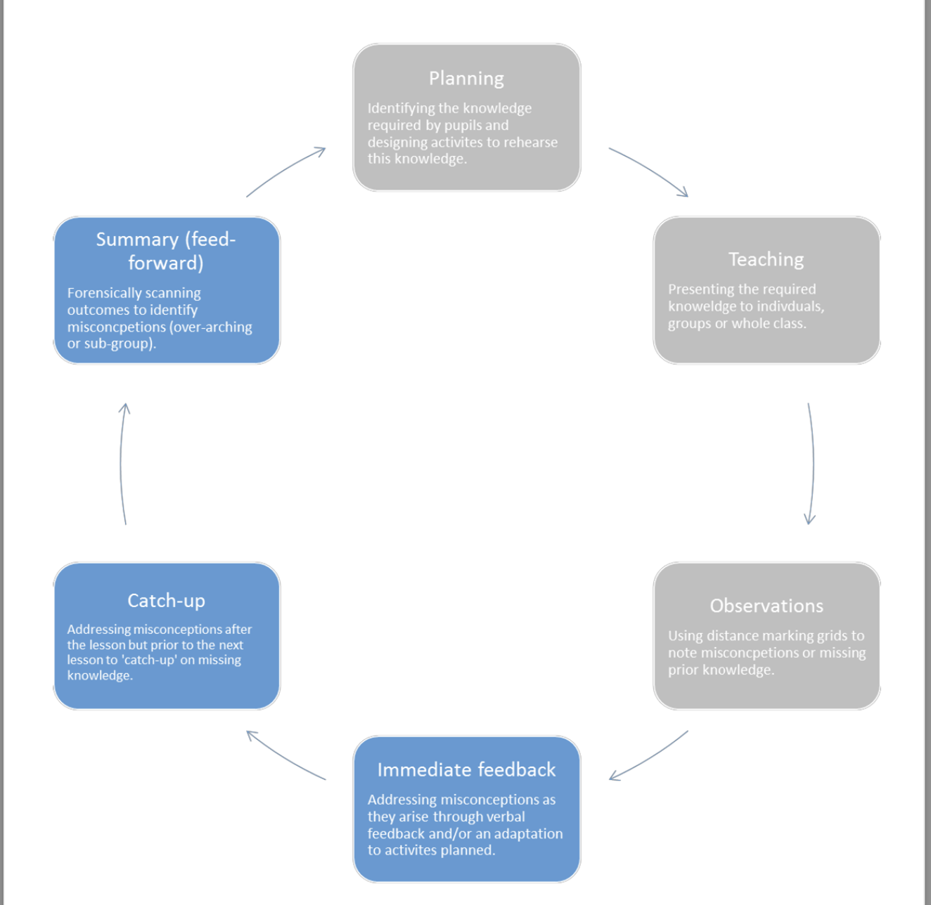

The importance of editing in our feedback cycle:
“Accepting work that pupils have not checked sufficiently and then providing extensive feedback detracts from pupils’ responsibility for their own learning, particularly in editing and drafting skills. Pupils should be taught and encouraged to check their own work by understanding the success criteria, presented in an age appropriate way, so that they complete work to the highest standard.” (DfE, 2016).
It is vital that opportunities for editing are planned within a unit. Such opportunities allow children to reflect on their own knowledge and make corrections or improvements when cognitive load is reduced e.g., number formation is the sole focus. For editing to be successful it must be focused by success criteria or knowledge organisers.

How we give feedback:
Type | What it looks like | Evidence  (for observers)
Immediate | - Takes place during a lesson with individuals, groups or the whole class.  - Includes the teacher and/or teaching assistant gathering assessments from their teaching e.g., whiteboard work, book work, verbal answers.  - Often given verbally to pupils for immediate actions.  - Praises effort and contributions.  - May involve the use of a teaching assistant to provide  support or further challenge.  - May re-direct the focus of teaching or the task. | Lesson observations; learning walks.
Responsive (catch-up) | - Takes place after the lesson or activity with individuals or groups.  - Re-addresses knowledge from the lesson or activity or addresses missing prior knowledge  - Often given verbally with time to rehearse knowledge immediately.  - An element of the child’s responses to catch-up are recorded in their workbooks to show progress over time. | Learning walks; catch-up observations; feedback grids; book looks.
Summary (feed-forward) | - Involves reading/looking at the work of all pupils at the end of a lesson or unit.  - Identifies key strengths and misconceptions for the whole class or sub-groups  - Takes place during the following lesson.  - Addresses over-arching strengths and misconceptions as well as specific misconceptions for the sub-groups  - Involves allocating time for editing based on the  feedback given or rehearsal of the knowledge. Editing is done in purple pen  - May involve some peer support | Planning looks; lesson observations; learning walks; book looks.

GUIDELINES
- Internal Examinations will be conducted twice a year
- During the year assessments must be criterion-referenced ensuring that all curriculum areas use the same measures for communicating attainment
- Learners must be given opportunities to achieve the targets set
- All learners should be made aware of what is being assessed (Learning Objectives and Learning Outcomes) before embarking on a task
- Subject Teachers will keep records of pupil progress which will include assessment results from Key Stage 2 till 4.

KS3
Pupils’ termly attainment data will be displayed as follows:
Emerging | Em | Learner has not met the term’s expectations
Developing | D | Learner is working towards meeting the term’s expectations
Securing | S | Learner has securely met the term’s expectations
Exceeding | Ex | Learner has met majority of the term’s expectations

KS4
Pupil data will be given in grades according to the 9-1 grading system. All externally moderated courses will follow the examination board’s assessment grading criteria

KS5
Pupil data will be given in grades according to the A -U / Distinction* - Pass grading system. All externally moderated courses will follow the examination board’s assessment grading criteria

MONITORING & EVALUATION
This policy will be reviewed annually at the Academic Board Meeting during the Summer Term unless there are significant changes made to assessment procedures. The policy will take account of national initiatives and the views of parents, teachers and governors.

Date approved by Board of Governors | Date of implementation | Date of next review
Sep 2023 | Sep 2023 | August 2024

